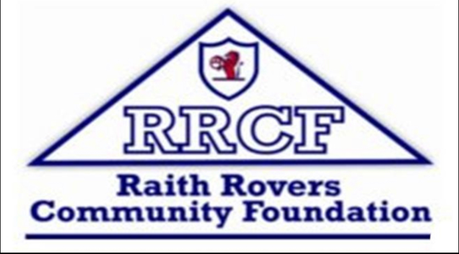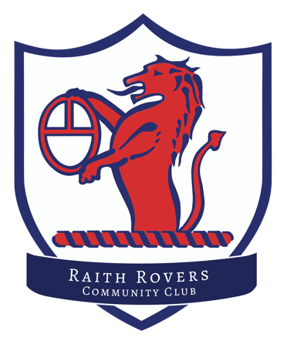

**Raith Rovers Community Club**

First Aid consent form

Under the guidance of the Scottish Football Association with the current return to play restrictions Raith Rovers CC first aiders are only permitted to administrate emergency First Aid

Should a player sustain a non-emergency/non-critical injury, the player’s parent or guardian will be contacted immediately by the clubs officials present if they are of an age they can not carry out self aid

For players to attend training sessions this medical form must be consented to on My Club Hub

I confirm that my contact details are correct in My Club Hub and that my child’s medical information is correct and up to date

I confirm that I understand and agree to the administration of emergency first aid only for my child

Parent or guardian